

“User Manual for the process of Jal Nigam Asset Mapping with the help of Mobile and Web Application”



23-05-2019
Table of Contents
INTRODUCTION: 3
Contents of Mobile Application: 3
Process Flow for Install and Use of App for Jal Nigam Department STEP 1: Application Installation 3
STEP 2: Device Registration 4
STEP 3: Sync Data 5
STEP 4: Mapping Asset 7
STEP 5: Upload Asset 8
Contents of Web Application- Administrator 11
STEP 1: Login 11
STEP 2: User Management 12
Activate or deactivate the mobile users 12
Pending for Approval: 13
Assign Work: 14
Step 3: Data Visualization: 15
View Mapped Asset 15
View Assets on map 17
Step 4: Logout 18
Contents of Web Application- User 19
Step 1: Data Visualization 20
View Mapped Asset: 20
View Assets on map 22
Step 2: Logout 23

Table of Figures

Figure 1: Mobile Application installation 5
Figure 2: Device Registration 6
Figure 3: Data sync 6
Figure 4: Data sync 6
Figure 5: Data sync 7
Figure 6:Data sync 7
Figure 7:Data sync 8
Figure 8: Mapping Asset 8
Figure 9: Mapping Asset 8
Figure 10: Mapping Asset 9
Figure 11: Mapping Asset 9
Figure 12: Upload Asset 10
Figure 13: Upload Asset 10
Figure 14: Upload Asset 10
Figure 15: Discard Asset 11
Figure 16: Upload Asset 11
Figure 17: Upload Asset 11
Figure 18: Admin login 12
Figure 19: Login credentials 12
Figure 20: Login 13
Figure 21:Admin home page 13
Figure 22: User management 13
Figure 23: Activate/deactivate Users 13
Figure 24: Details of users 14
Figure 25: Activate user 14
Figure 26: Deactivate user 14
Figure 27: Pending Approval 14
Figure 28: Approve user 15
Figure 29: Delete user 15
Figure 30: Assign work 15
Figure 31: Assign work 16
Figure 32: Reset work 16
Figure 33: view mapped asset 16
Figure 34: Search mapped asset 17
Figure 35: List of searched mapped asset 17
Figure 36: View detail of mapped asset 17
Figure 37: Detail of asset 17
Figure 38: view map of mapped asset 18
Figure 39: mapped asset on map 18
Figure 40: View assets on map 18
Figure 41: search assets 18
Figure 42: assets on map 19
Figure 43: Profile icon 19
Figure 44: Logout 19
Figure 45: Request OTP 20
Figure 46: User login 20
Figure 47: Email is not correct 21
Figure 48: User home page 21
Figure 49: View mapped asset-user 21
Figure 50: Search mapped asset of user 22
Figure 51: List of assets of user 22
Figure 52: View detail of asset- user 22
Figure 53: Details of asset 22
Figure 54: View map 23
Figure 55: Asset on map 23
Figure 56: View assets on map 23
Figure 57: Search list of assets of user 23
Figure 58: assets on map 24
Figure 59: Profile icon of user 24
Figure 60: Logout 24

INTRODUCTION:
To Map the location of Jal Nigam department assets a module has been developed which includes two applications one is Mobile based and second is Web based application. With the help of this application authorised users (by department) will be able to map the list of assets and upload the location and information to the server which shall be further can be visualized by the department with the help of web application also developed by MAP_IT.

Mobile based application: To map the location of assets with the help of mobile registered device,

Web Based Application: This application includes two parts one is for Administrator to authorise the mobile user and assign the work to them and second part is for mobile users to visualize the data uploaded by them.

Part 1 Mobile Application

Contents of Mobile Application:
- Application Installation
- Device Registration
- Sync Data
- Mapping Asset
- Upload Asset

Process Flow for Install and Use of App for Jal Nigam Department
STEP 1: Application Installation

- First user should search the application named as ‘M.P. Jal Nigam’ on google play store, and click the install button to install the application on mobile device,
- Or click the below link to install the application,
https://play.google.com/store/apps/details?id=mapitgis.jalnigam.release&hl=en&rdid=mapitgis.jalnigam.release
- After clicking the install button , wait till the installation get completed,
- After installation user should be able to see the icon in the mobile device,

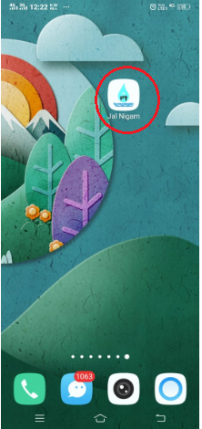
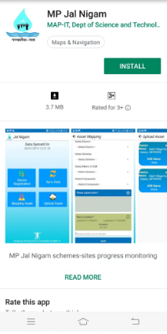

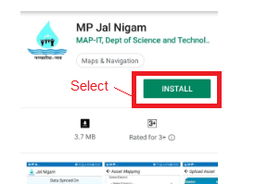

Figure 1: Mobile Application installation

STEP 2: Device Registration

If user is installing and using the application for the first time, then user needs to register the mobile application first which will be approved by department, to register the device follow the steps mentioned below:
- Open the application in your device by selecting the icon,
- Clicking the icon open the home page of application,
- On the home page, selects the icon named as ‘Device registration’,
- Clicking the icon shall ask to allow the permission, click ‘Allow’
- Next a form shall open where user should fill the following details:
- Designation
- Full Name
- 10 digit Mobile number
- Email ID (Please type the correct email id as it will be further use to login in web application)
- Gender
- After filling all the information of the form, click ‘Register’
- User should see a small notification popup as ‘Device Registered successfully’

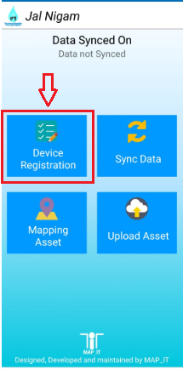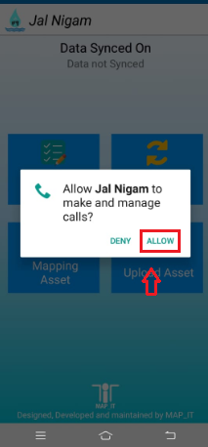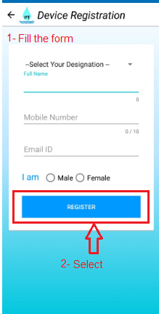
Figure 2: Device Registration

STEP 3: Sync Data
After registering the device successfully, next user should sync the data in the mobile device, select the icon sync data, but first device should be activated by the Administrator/Department,

- First click the icon named as ‘Data Sync’
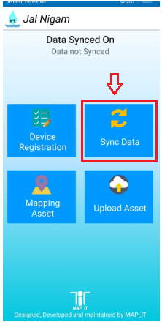
Figure 3: Data sync

- A notification will pop up for confirmation, click ‘OK’

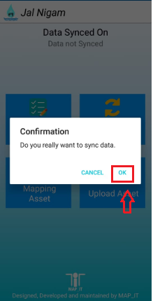
Figure 4: Data sync
- If the device is not activated, a notification will pop up as ‘Your account is deactivated. Please contact administrator to activate your account’, then please contact the department,

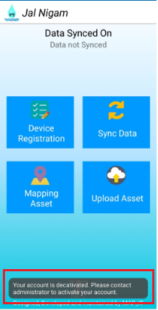
Figure 5: Data sync
- If the device is activated, but work is not assigned then a notification will pop up as ‘No work assigned yet, please contact the administrator to assign the work’, then please contact the department,

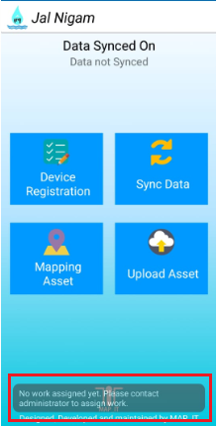
Figure 6: Data sync

- If the device is activated and work is also assigned then a notification of success will pop up, click ok

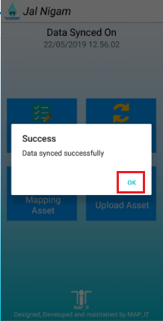
Figure 7: Data sync
- After syncing the data user will be able to the list of all the data assigned by the department/administrator,

STEP 4: Mapping Asset
With the help of this user should be able to map the assigned assets,
- To start Asset mapping select the icon ‘Mapping Asset’,
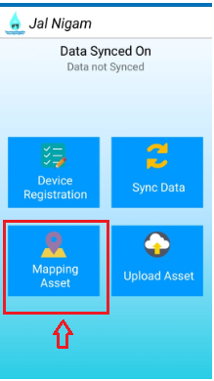

Figure 8: Mapping Asset
- Clicking the icon will pop up a one-time notification, click ‘Allow’,

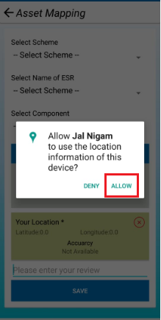
Figure 9: Mapping Asset

- Next fill the information of the form as,
- Select scheme
- Select Name of ESR
- Select Component
- Capture the photo of asset
- Write review if any
- After filling all the information click save,

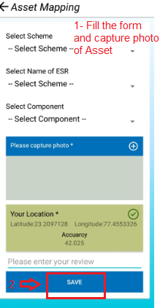
Figure 10: Mapping Asset

- A notification will pop up as ‘Saved successfully’, click ‘ok’,

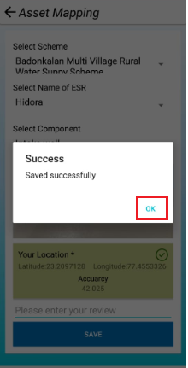
Figure 11: Mapping Asset
- User can map one or more than one asset and save them locally.

STEP 5: Upload Asset
With this user will be able to upload all the mapped asset in the device on server,
- Click the icon named as ‘Upload Asset’

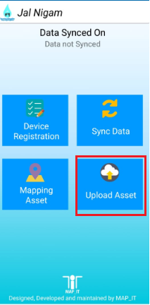
Figure 12: Upload Asset
- Clicking will open the page of list of mapped assets,

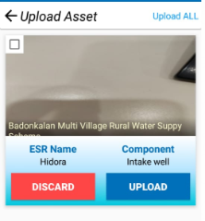
Figure 13: Upload Asset
- User can upload asset by clicking the ‘Upload’ button,

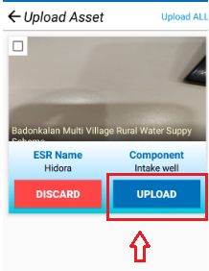
Figure 14: Upload Asset
- Or user can Discard the asset by clicking the ‘Discard’ button,

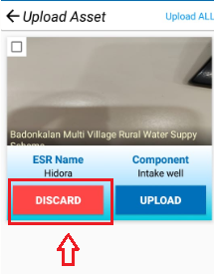
Figure 15: Discard Asset
- User can select one or more than one asset and can ‘upload/Discard’ all the selected asset at one time,

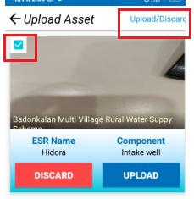
Figure 16: Upload Asset
- User can upload all the assets by selecting ‘Upload all’

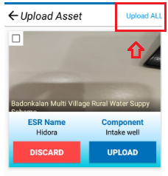
Figure 17: Upload Asset

Part 2A Web Application- Administrator Login

Contents of Web Application- Administrator
- Login
- User Management
- Activate/Deactivate Users
- Pending for Approval
- Assign Work
- Data Visualization
- View Mapped Asset
- View Assets on Map
- Logout

STEP 1: Login
- To login the web application open the link mentioned below:
http://geoportal.mp.gov.in/mpjalnigam/
- Clicking the link will open a login window,
- Select ‘Admin login’ to login the web application as administrator,

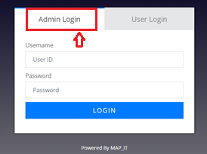
Figure 18: Admin login
- Fill username and password provided by the department

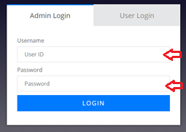
Figure 19: Login credentials

- After typing credentials, click ‘login’,

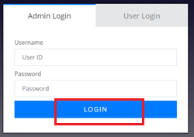
Figure 20: Login
- Clicking the login button will open the home page for administrator,

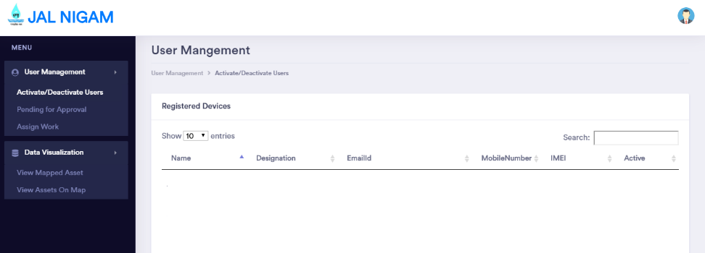
Figure 21: Admin home page

STEP 2: User Management
- Click the user management from the Menu panel,

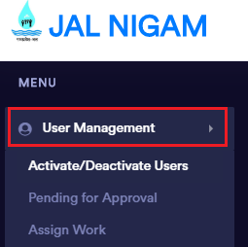
Figure 22: User management

Activate or deactivate the mobile users

- To activate or deactivate the mobile user, select ‘Activate/Deactivate’ from the panel

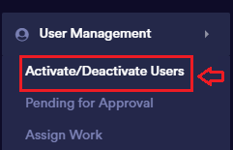
Figure 23: Activate/deactivate Users
- Clicking will show the list of all the registered mobile users with the basic information like name, Designation, Email id, Mobile number, IMEI

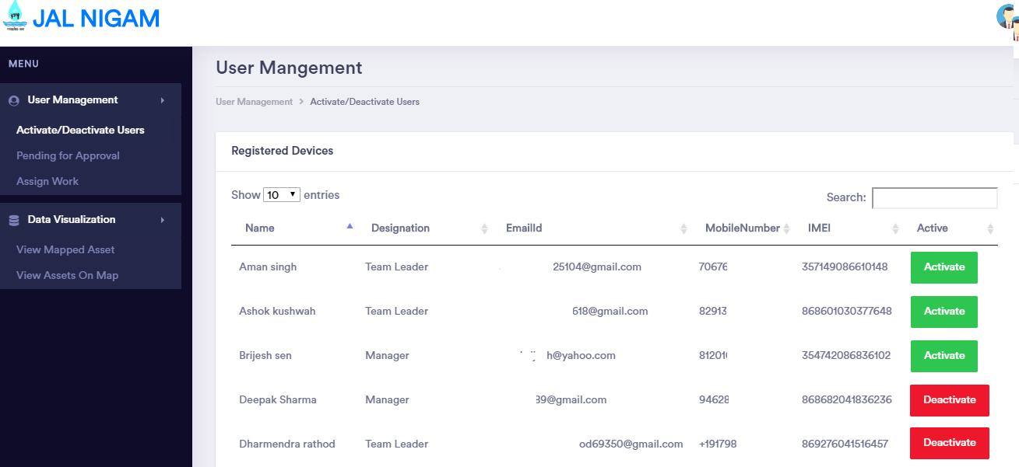
Figure 24: Details of users
- To activate the user click the ‘Activate’ button beside the details of the respective user,

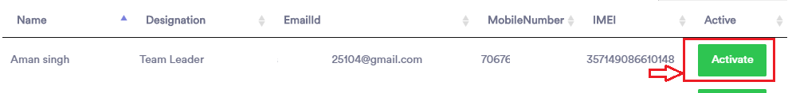
Figure 25: Activate user

- To deactivate the user click ‘Deactivate’ Button beside the details of the respective user,

Figure 26: Deactivate user

Pending for Approval:
Administrator can approve the mobile user or delete their request,
- To approve or delete the mobile user, select ‘Pending for Approval’ from the panel

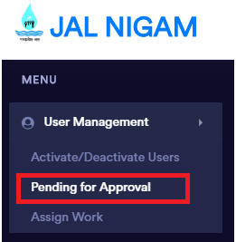
Figure 27: Pending Approval

- To approve the request of mobile user, select ‘Approve’ button beside the details of respective user,

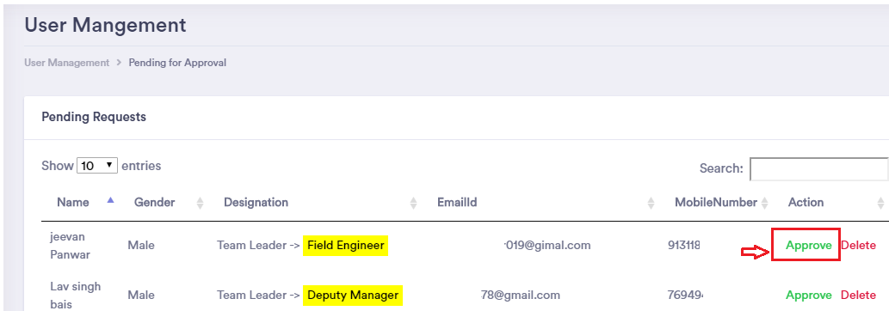
Figure 28: Approve user
- To delete the request of mobile user, select ‘Delete’ button beside the details of respective user,

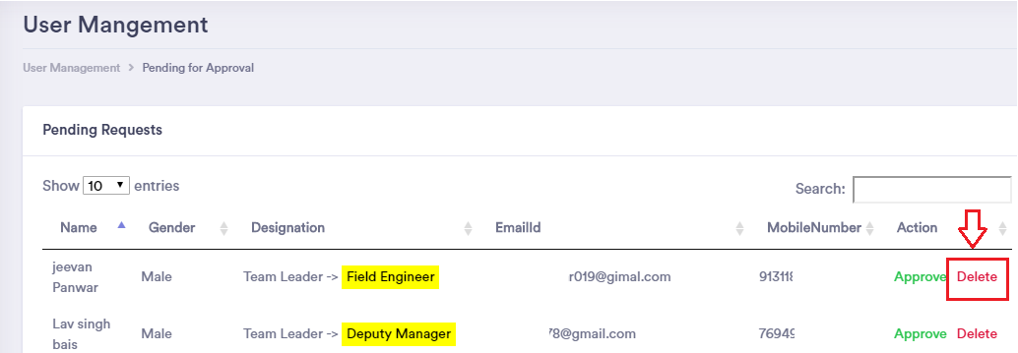
Figure 29: Delete user

Assign Work:
To assign work to any mobile user select ‘Assign work’ from the menu panel:

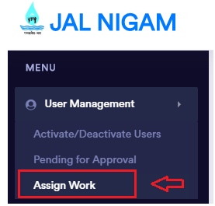
Figure 30: Assign work
Next select name of the
- ‘User’,
- then select ‘Scheme’
- and ‘ESR’,
- Select the button ‘Assign’ to confirm the work to respective selected user,

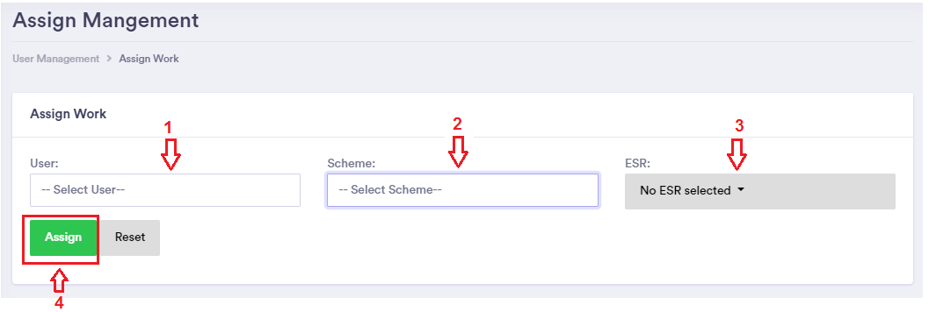
Figure 31: Assign work

- To remove any previous work of the user, select the ‘User’,
- Can see the list of previous assigned work to the user
- And select the button ‘Reset’.

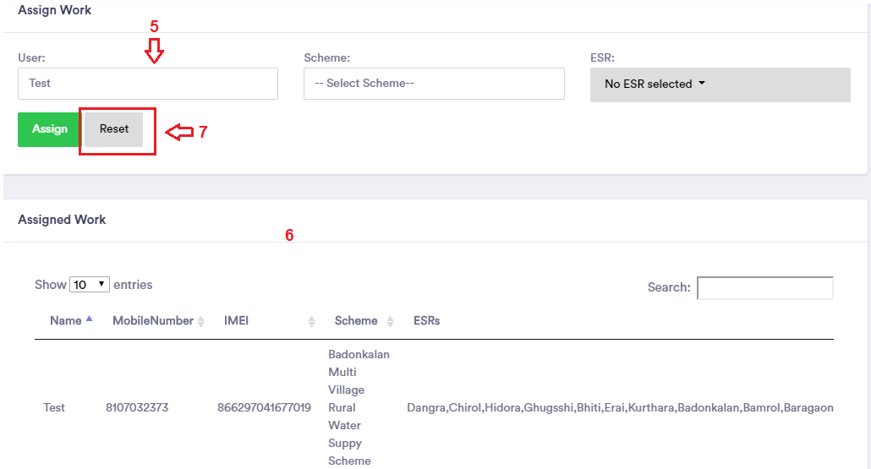
Figure 32: Reset work

Step 3: Data Visualization:
Administrator can visualize list and details of data mapped by the mobile users as user-wise or scheme-wise or ESR-wise or Component-wise,

View Mapped Asset
To see the list of mapped assets select ‘View Mapped Asset’ from the ‘Data visualization’ of Menu panel,

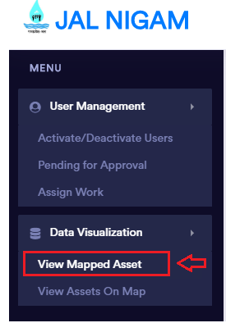
Figure 33: view mapped asset
- Select ‘User’ then select ‘Search,
- or ‘Scheme’ then select ‘Search,
- or ‘ESR’ then select ‘Search,
- or ‘Component’
- select ‘Search’ button

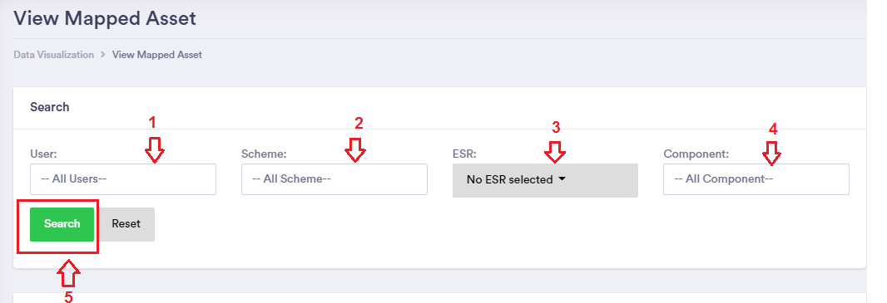
Figure 34: Search mapped asset
- Clicking the search button will show the details with respective searched criteria,

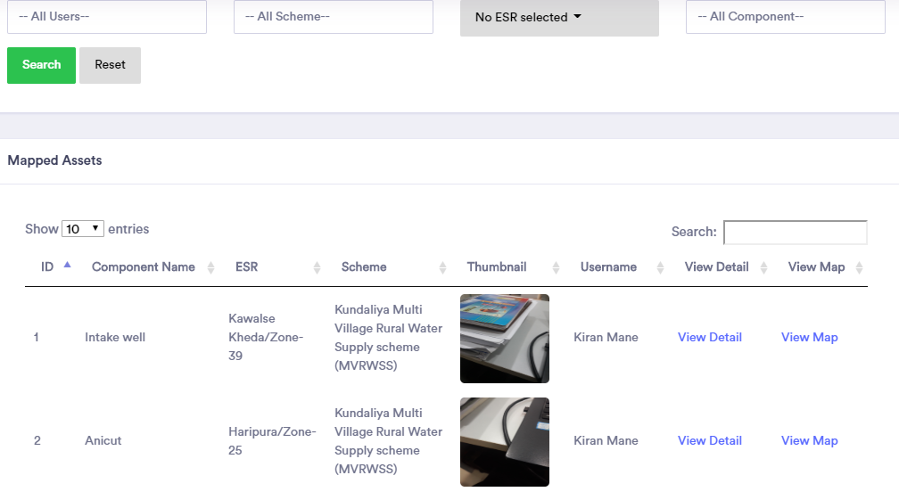
Figure 35: List of searched mapped asset
- To see the details with respect to any mapped assets, select ‘View details’

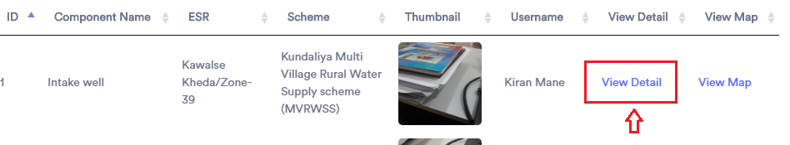
Figure 36: View detail of mapped asset

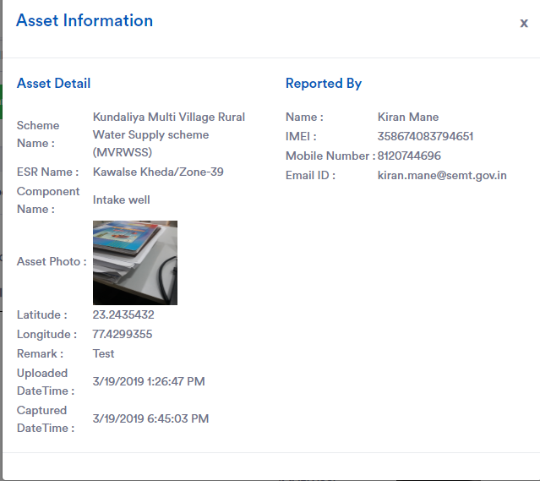
Figure 37: Detail of asset

- To see the details of any assets on map, select ‘View Map’

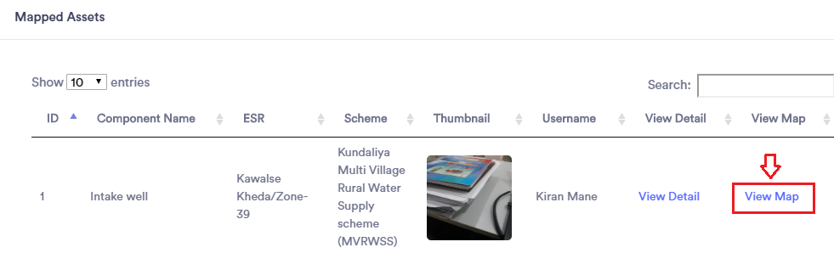
Figure 38: view map of mapped asset
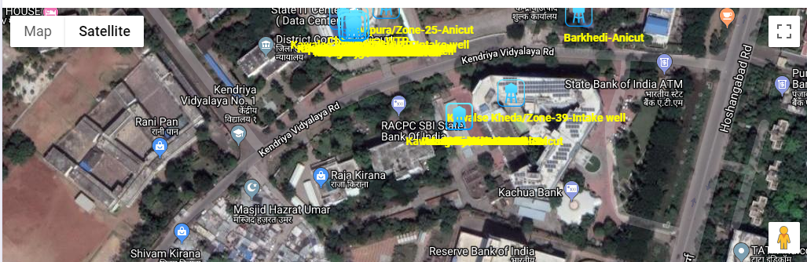
Figure 39: mapped asset on map

View Assets on map
To visualize assets on map user, select ‘View Assets on map’ from the menu panel,

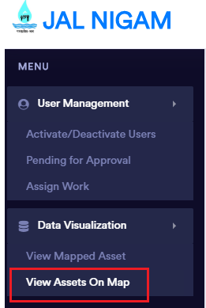
Figure 40: View assets on map

- Select ‘User’ then select ‘Search,
- or ‘Scheme’ then select ‘Search,
- or ‘ESR’ then select ‘Search,
- or ‘Component’
- select ‘Search’ button
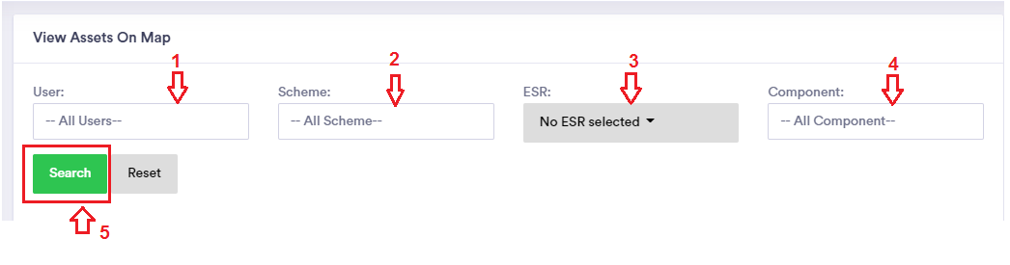
Figure 41: search assets
- Clicking ‘Search’ will zoom the asset/s on the map as per the searched criteria,

Figure 42: assets on map

Step 4: Logout

- To move out from the application click the profile icon and select ‘Logout’.

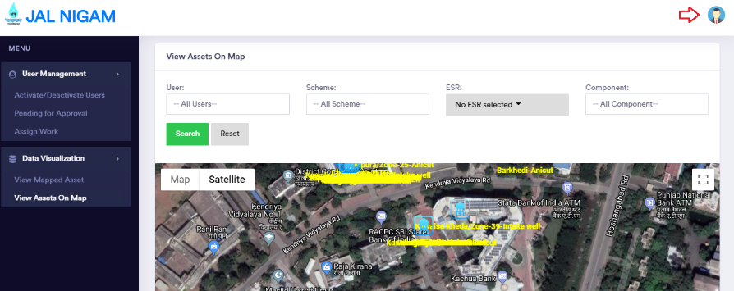
Figure 43: Profile icon
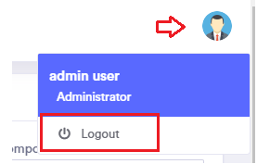
Figure 44: Logout

PART 2B: Web Application- User Login

Contents of Web Application- User
- Login
- Data Visualization
- View Mapped Asset
- View Assets on Map
- Logout

Any registered and approved mobile user can visualize his/her assigned work or the assets mapped, first go to the web link http://geoportal.mp.gov.in/mpjalnigam/, clicking the link will direct to the login page of the Jal Nigam web application then,

- To login select ‘User Login’,
- type the same registered email id used for mobile application,
- Select ‘Request OTP’,
- Check your email for OTP (wait for some time as it will take up to a minute),
- Type OTP as received in email,
- and click ‘Login’

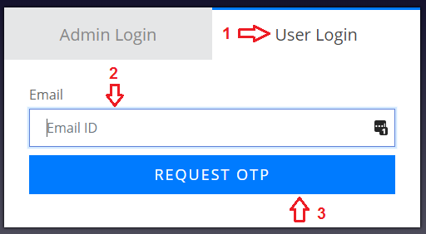
Figure 45: Request OTP

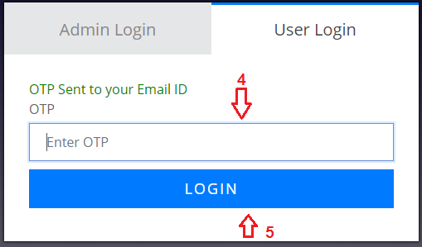
Figure 46: User login

Note: Please type the correct email id same as used while device registration, if the email id is not registered then a notification will pop up as ‘User does not exist’

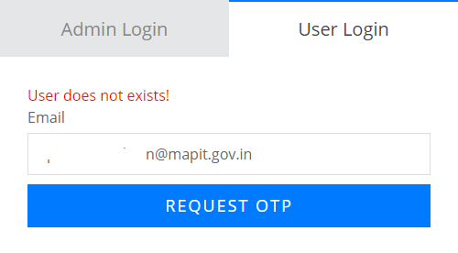
Figure 47: Email is not correct
Clicking the login will open the home page of the application,

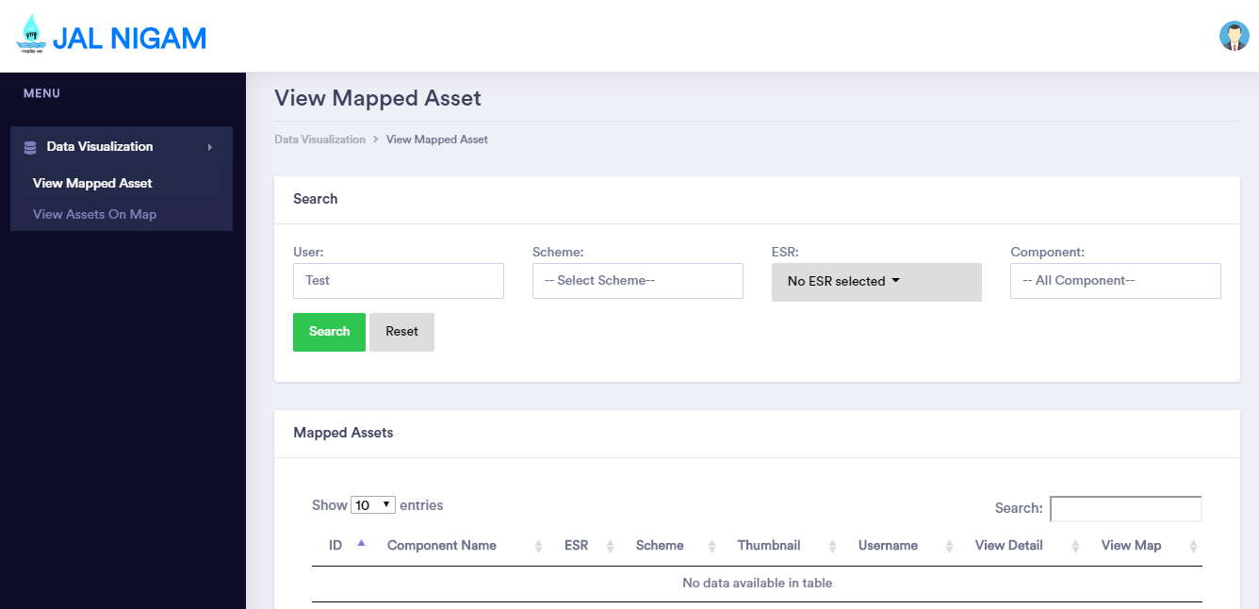
Figure 48: User home page

Step 1: Data Visualization
With the help of this section, user can visualize data assigned to the respective mobile user (as typed email id),

View Mapped Asset:
To visualize the Login mobile user’s data, select ‘View mapped asset’ in the menu panel,

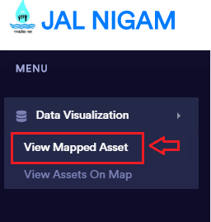
Figure 49: View mapped asset-user
- Select ‘User’ (can see only user with respect to the email id) then select ‘Search,
- or ‘Scheme’ then select ‘Search,
- or ‘ESR’ then select ‘Search,
- or ‘Component’
- select ‘Search’ button


Figure 50: Search mapped asset of user
- Clicking the search button will show the details with respective searched criteria,


Figure 51: List of assets of user
- To see the details with respect to any mapped assets, select ‘View details’


Figure 52: View detail of asset- user

Figure 53: Details of asset

- To see the details of any assets on map, select ‘View Map’


Figure 54: View map


Figure 55: Asset on map

View Assets on map
To visualize assets on map user, select ‘View Assets on map’ from the menu panel,
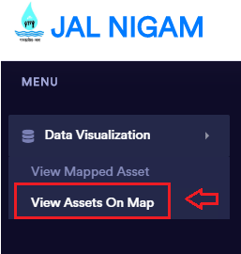
Figure 56: View assets on map

- Select ‘User’ (can see only user with respect to the email id) then select ‘Search,
- or ‘Scheme’ then select ‘Search,
- or ‘ESR’ then select ‘Search,
- or ‘Component’
- select ‘Search’ button

Figure 57: Search list of assets of user
- Clicking ‘Search’ will zoom the asset/s on the map as per the searched criteria,

Figure 58: assets on map

Step 2: Logout

- To move out from the application click the profile icon and select ‘Logout’.
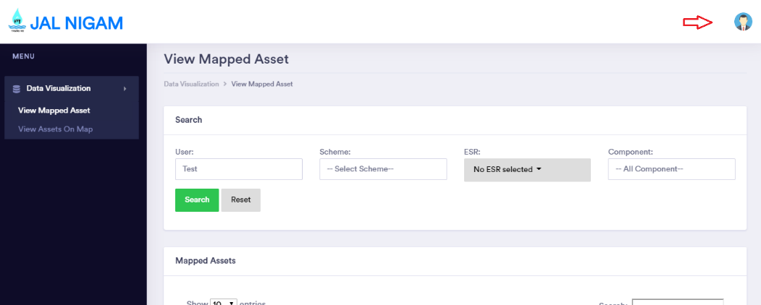
Figure 59: Profile icon of user

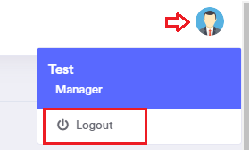
Figure 60: Logout

***********************************End of Document*********************************

